Biographies
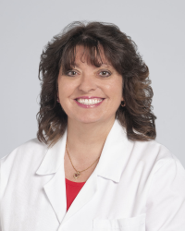 Kimberly Sherry RN, MSN, PCCN, EMT is a Simulation Education Specialist and the Program Manager for the AHA Department’s Resuscitation Simulation in situ Program at Cleveland Clinic. She serves as a member of multiple Cleveland Clinic System code review committees and works with clinical, quality and education stakeholders to provide impactful unit-based simulation to reinforce instructor-led simulation, reduce performance decay and improve caregiver’s readiness to act in emergencies. Additionally, she is an ACLS, PALS, and BLS instructor.
Prior to her current position, she was the charge nurse in cardiothoracic surgery in the Heart, Vascular and Thoracic Institute at the Cleveland Clinic for over 20 years and continues in that department in a PRN role. She also performed as the unit-based educator.
Her academic interests include inter-professional education, the effects of rapid response teams on in-hospital cardiac arrest rates, and the impact of latent safety threats on patient safety.
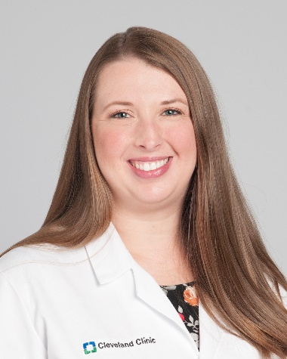 Maureen Washock BSN, RN, CPN, CHSE, is a Simulation Education Specialist with Resuscitation Simulation within Nursing Education at the Cleveland Clinic and the co-Chair of the Faculty Development Workgroup for the Simulation and Advanced Skills Center Global Advisory Board. She has been working in simulation as an educator within interprofessional and nursing education since 2009, with a focus on pediatrics and in situ simulation. Her simulation interests include simulation for patient safety and quality improvement and global alignment of simulation processes to support the Healthcare Simulation Standards of Best Practice. She has presented numerous times since 2011 to disseminate the exemplary work being done in simulation at the Cleveland Clinic at the Society of Simulation in Healthcare’s (SSH) International Meeting of Simulation in Healthcare (IMSH), International Nursing Association for Clinical Simulation and Learning’s (INACSL) annual conference, Professional Nurse Educators Group (PNEG) annual conference, American Academy of Pediatrics (AAP) Section on Simulation and Innovative Learning Methods (SOSILM) annual meeting, and Laerdal’s Mini Simulation User Network (mini- SUN) conference, and is an active member in several sections and special interest groups in the Society of Simulation in Healthcare. Maureen is currently working towards her Master of Science in Nursing Education.

